You shall have no other gods

A god is that to which we look for all good in which we find refuge in every time of need. To have a god is nothing else than to trust and believe in him with our whole heart. If your faith and trust are right, then your God is the true God. On the other hand, if your trust is false and wrong, then you do not have the true God.
Luther's Large Catechism, Commandments, 2,3
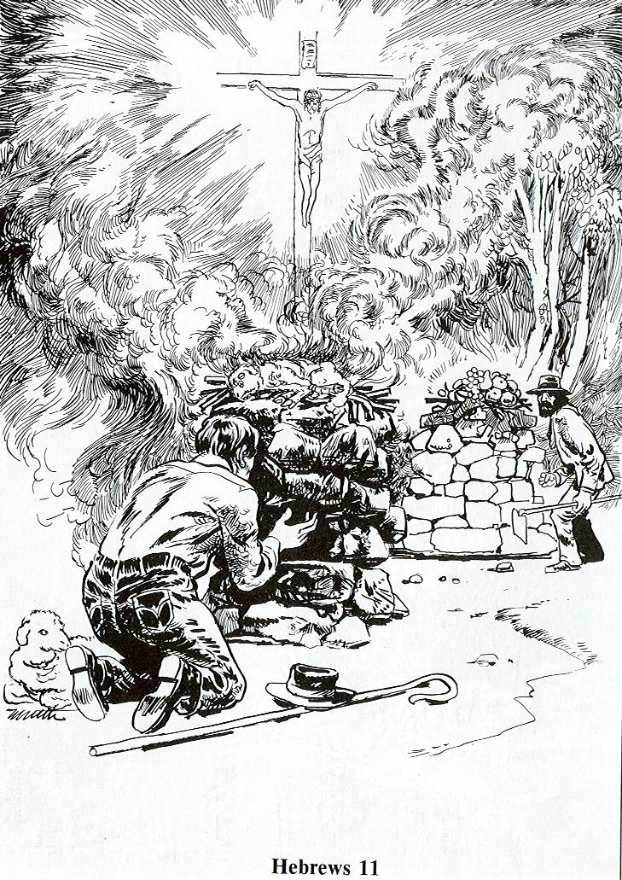
INTRO:
-- Think about what’s most important to you.
-- Write on example of what’s most important to you on each of the notecards

Read Genesis 4:2-5; Hebrews 11:4
1. Compare Cain’s offering with Abel’s.
- What is similar about them?
- What is different?
-- Cain brough some of the fruits of the soil
--Abel brought fat portions of the firstborn of his flock (the very best he had)

(It wasn’t what Cain brought that caused God not to accept it, but the why. His attitude was wrong)
2. Describe Cain’s attitude toward the LORD as you look at the picture. –angry / threatening

3. Describe Abel’s attitude. Humble / reverent
4. Discuss: When is my attitude like Cain’s? When is it like Abel’s? Do things just because I have to or because I think they will get benefit me I am like Cain
--Have an attitude of thanks and praise (faith in God) that shows in my actions – like Abel
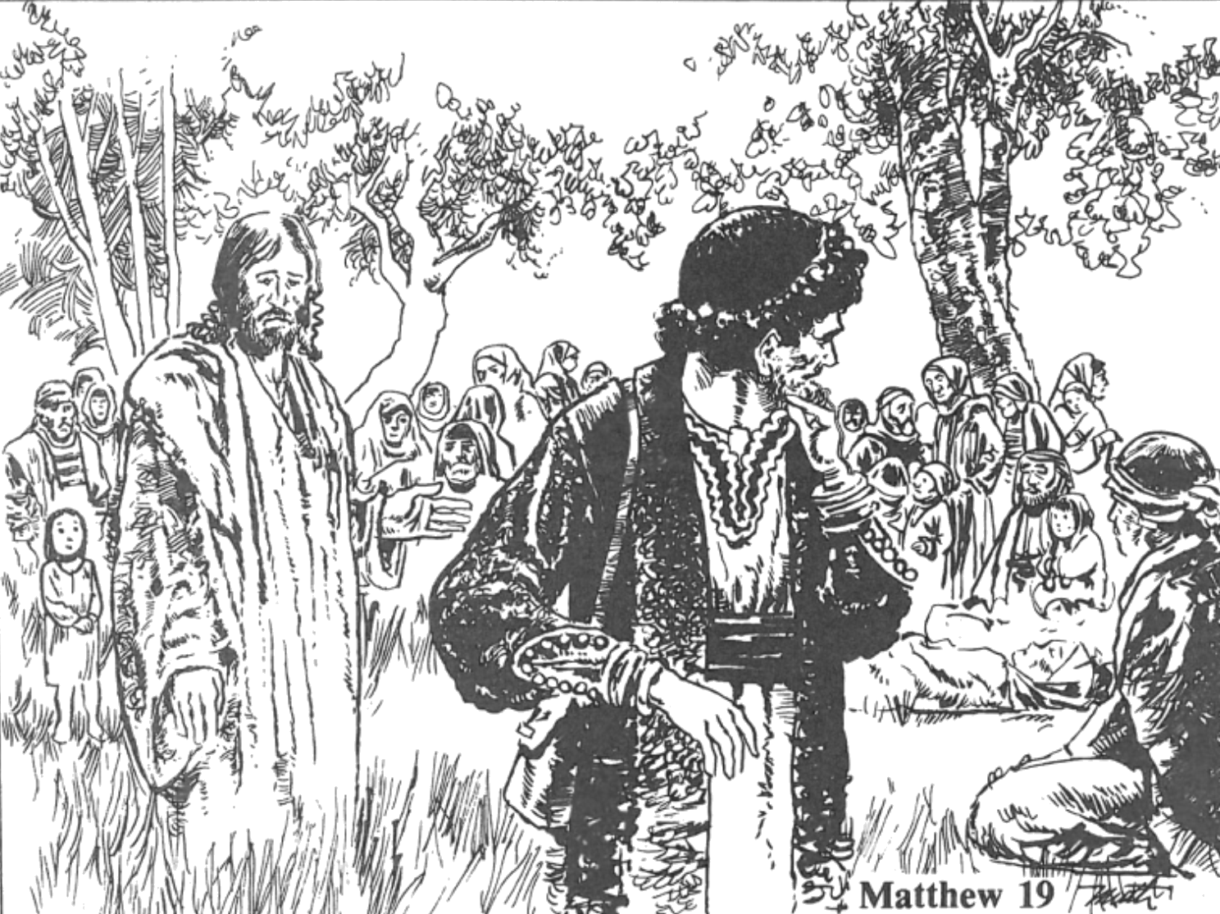

Read Matthew 19:16-26
1. What did the young man want to know?
-- what good things he could/had to do to earn eternal life

2. What did Jesus tell him?
--Keep all the commandments

3. What did the young man think he had done?
--kept them all

4. What did Jesus tell him to do if he wanted to be perfect?
--sell all he had, give it to poor, and follow Jesus

5. How did the young man feel when he heard Jesus' answer?
--He was sad because he was very rich

6. In your group, name one thing that would be difficult for you to give up.
What makes it so difficult?

What are my idols?
- Where does your mind wander most often during alone or down time?
- What good thing have you turned into an ultimate thing?
- What do you spend most of your money and time on?

